**THE WHOLE AREA OF LONDON BOROUGH OF HARROW**

**PUBLIC SPACES PROTECTION ORDER**

**This Order relates to the whole borough of the London Borough of Harrow, as shown edged black on the attached plan**

1**.** In this Order:

**‘Anti-Social Behaviour’** refers to section 59 (2) (a)-(b) of the Anti-Social Behaviour, Crime and Policing Act 2014 and means: activities carried out, or which are likely to be carried out, in a public space which have a detrimental effect on the quality of life those in the locality. This also means behaviour likely to cause harassment, distress or alarm to one or more other person. This can include, but is not limited to, littering, verbal abuse, obstructing the highway, illegal drug use, urinating or, spitting

‘**The designated area**’ refers to any public space to which the public or a part of the public has access (S 74(1) of the Anti-Social Behaviour, Crime and Policing Act 2014). This can be with payment, or with express or implied permission. This can include businesses and communal areas of housing blocks but excludes residential premises. Prohibitions/requirements may vary for each designated area and will be highlighted accordingly on the attached plans.

**‘Authorised officer**’ refers to: police officer, police community support officer, or any other person designated to enforce the Order by Harrow Council. You can require any authorised officers to produce authorisation before enforcing the Order.

‘**Psychoactive substanc**es’ refers to section 2(1) and section 2(2) of the Psychoactive Substances Act 2016: “any substance which –

* (a) is capable of producing a psychoactive effect in a person who consumes it, and
* (b) is not an exempted substance”
* Laughing gas (nitrous oxide or balloons), khat, spice, and mephedrone (drone) are examples of psychoactive substances referred to in this Order.

**‘Proper control’** means a dog being on a lead or muzzled if the dog requires it, or otherwise being at heel / close enough to the person in charge that it can be restrained if necessary or responding immediately to voice commands

**‘A receptacle’** is defined as any object capable of holding faeces for disposal and does not include an item of clothing, handbag, or purse.

**‘Removal of faeces from land’** will include placing the faeces in a receptacle on the land which is provided for that purpose, or for the disposal of waste.

**‘Footpaths and Verges’** Applies to any footway or footpath, maintainable at the public expense, or any grass verge managed by the Local Authority, and which is adjacent to the carriageway or footway of a highway, including adjoining footpaths within the restricted area. This prohibition will not apply where the reason is for permitted access or for emergency vehicles gaining access to, or attending to, an incident

**‘Illegal advertising’** includes anyone Fly-posting including the unlawful posting of notices, signs or banners to street furniture or a person or body who benefits from the fly posting.

**‘Illegal or Unauthorised Street Trading’** includes persons selling from bags, trolleys, Vehicles or any other mobile means.

2. The London Borough of Harrow, in accordance with Section 59 (7)(a) of the Anti-Social Behaviour, Crime and Policing 2014, identifies the following activities in the designated areas, highlighted in section 3 to 12

of this Order, as having had a detrimental impact on the quality of life of those in the locality, or it is likely that they will have such an effect

3. **The Whole Borough as shown edged black on the attached map in Appendix 1 (the designated area)**

* Street drinking while engaged in anti-social behaviour
* Occupying any vehicle or caravan
* Consumption, use, and/or possession of psychoactive substances
* Controlling and clearing up after dogs
* Provide your name and address
* Urinating/defecating and/or spitting in public
* Careless disposal of cigarettes and other material
* Highways and Vehicles
* Smoking in Play Areas
* Illegal advertising or running events
* Fires and fireworks
* Congregating groups engaged in anti-social behaviour

4. **Housing Estates as shown highlighted on the attached plan in Appendix 2 (‘the designated area’):**

* Obstructing the entrances to or exit from any building, or the free passage of people on or in stairwells
* Causing an obstruction which prevents or hinders the free passage of pedestrians or vehicles
* Unroadworthy vehicles
* Fly-tipping
* Bird feeding

5. **Parks as shown highlighted on the attached plan in Appendix 3 (‘the designated area’)**

* Littering
* Dog Control
* Driving vehicles on park land without prior permission
* Unauthorised activities

6. **Town Centres as shown highlighted on the attached plan in Appendix 4 (‘the designated area’)**

* Intimidating and/or aggressive begging
* Obstructing access to business premises during opening hours
* Leaving commercial waste in public spaces for an unreasonable length of time
* Use of amplification
* Financial Agreements on the Street
* Placing of tables, stands, or other furniture / fixings
* Distribution of leaflets
* Illegal or Unauthorised Street Trading
* Feeding of Birds and Vermin

7. **Bentley Priory, Pinner Memorial Park and The Viewpoint as shown highlighted on the attached plan in Appendix 5 (‘the designated area’)**

* Bentley Priory - Dog control
* Pinner Memorial Park feeding ducks and pigeons
* The Viewpoint indecent behaviour and causing damage

Due to the volume of reports of these activities and behaviours, the Council is satisfied that the effect, or likely effect, of the activities is, or is likely to be, of a persistent or continuing nature and these activities are unreasonable and justify the restrictions imposed by the notice and that it is in all the circumstances expedient to make this Order for the purpose of reducing anti-social behaviour in a public place.

The requirements and prohibitions set out below will relate to either the whole borough or parts of the London Borough of Harrow and will be stated as such.

The London Borough of Harrow, being thereby satisfied that the conditions in Section 59 of the Act have been met, hereby makes the following Order:

**8. The Whole Borough**

As shown edged black on the attached plan in Appendix 1 (‘the designated area’)

**Requirements - In all public spaces within this designated area, you are required to:**

**1) Street drinking while engaged in anti-social behaviour**

a. Stop drinking alcohol, or anything which the authorised officer reasonably believes to be alcohol, if asked to do so by an authorised officer because they reasonably believe that you have been engaging in anti-social behaviour.

b. If you have been asked to stop drinking alcohol by an authorised officer and have not, without reasonable excuse, complied with their request, you must surrender any cans, bottles, or other containers of alcohol or what can reasonably be believed to be alcohol

**2) Occupying any vehicle or caravan**

1. Remove all vehicles or caravans within 12 hours and disperse from the area if asked to do so by an authorised officer, because you have been occupying a vehicle or caravan as part of a group where an authorised officer is satisfied that there have been substantiated reports of crime or anti-social behaviour relating to at least one or more person/s. A report can be made by any person and will be substantiated by a Council officer or agent of the Council carrying out the functions of the Council, or by a Police officer, witnessing the crime or anti-social behaviour.

**3) Consumption, use, and/or possession of psychoactive substances**

a. Surrender any psychoactive substances or associated paraphernalia you possess or any items reasonably believed to be such by an authorised officer.

**4) Controlling and clearing up after dogs**

1. Remove the dogs faeces forthwith from land within the “the designated area”, unless you have a reasonable excuse for failing to do so.
2. Have in your possession, and produce on request by an authorised officer, a receptacle suitable for picking up dog faeces from the land.
3. Where deemed by an Authorised Officer to be responsible for a dog(s) not under proper control or causing a nuisance, to put that dog on a lead.

**5) Provide your name and address**

a. Give your name and address to an authorised officer if asked to do so to deal with any of the behaviours identified in this Order (e.g. street drinking; groups engaged in ASB; fly-tipping; urinating, defecting and/or spitting in a public or communal space; littering; using drugs and/or psychoactive substances; occupying a vehicle or caravan while engaged in ASB)

**Prohibitions - In all public spaces within this designated area, you are prohibited from:**

**6) Controlling you dogs**

a. Allowing a dog(s) under your control to enter and remain in area where a Harrow Council notice specifies that dogs are not allowed or when asked to remove them from that area by an Authorised Officer.

b. To be solely in charge of more than 4 dogs at the same time in a public place, whether on leads or not.

**7) Psychoactive substances (legal highs)**

a. Possessing and/or smoking, injecting, inhaling, or otherwise consuming any psychoactive substances.

**8) Urinating/defecating and/or spitting in public**

a. Urinating and/or defecating in a public and/or communal space.

b. Depositing saliva, mucus, or any other product from the mouth or nose without reasonable excuse or attempt to collect or eradicate the saliva or product.

**9) Careless disposal of cigarettes and other material**

a. Disturbing materials/items left as recycling or donation at charity shops or recycling points and spreading or leaving as fly tip or waste.

b. Disposing of any cigarettes/cigars/roll-ups into a bin without first fully and properly extinguishing them.

**10) Highways and Vehicles**

a. Causing an obstruction on a Public Highway, Path or Pavement by placing objects such as waste bins, cones or other restrictions which limit legitimate access without authorisation.

b. Causing an unnecessary obstruction or limiting legitimate access to any shared access or path.

c. Repairing or storing vehicles for repair or sale in the street or other location without the landowners express permission will be an offence

d. Depositing any unroadworthy vehicle, these being any vehicles that are untaxed, uninsured, and/or without a valid MOT. Any vehicles declared with a Statutory Off-Road Notification (SORN) cannot be deposited unless there is prior permission.

e. Being in charge of any vehicle left idling when parked whether attended or otherwise, unless as part of an official examination or assessment by a competent mechanic

f. Reckless use or riding of any bike or scooter, including the use of e-scooters and e-bikes so as to cause nuisance or annoyance, on pavements paths and pedestrian only areas.

g. Causing nuisance by inappropriate use of vehicles speeding or racing; performing stunts (including but not limited to performing doughnuts, skidding, handbrake turns, wheel spinning, being verbally abusive, swearing and intimidating to members of the public.)

h. Causing or allowing loud amplified music or other very loud noise to be emitted from a motor vehicle or from a portable device in a public place.

i. Dropping or depositing litter directly or from a vehicle or who abandons and leaves behind on the highway any bottles, cans, canisters, packaging, cigarette waste or other waste material of any form

j. Driving over or parking on Footways, Footpaths and Verges

**11) Smoking in Play Areas**

a. Smoking of any tobacco or tobacco related product, smokeless tobacco product including electronic cigarettes, herbal cigarettes or any illegal substance, within the boundary of the children’s play areas

**12) Illegal advertising or running events**

a. Placing advertisement or benefitting from an advert on the highway or roadside without the Authority’s or landowner’s prior written permission

b. Promoting or running a musical/entertainment event which is not approved by the Safety Advisory Group or licensed by Harrow Council or encouraging other person(s) to do so.

**13) Fires and fireworks**

a. Lighting of fires or using barbeques in a public place not designated for such use or part of an organised event approved through the responsible authority.

b. Use of fireworks in a public place, in streets or adjacent to a public park or nature reserve without the written consent of the responsible authority

**14) Congregating groups engaged in anti-social behaviour**

a. Loitering within the restricted area if you are causing, or reasonably perceived to be causing, nuisance, intimidation, harassment, alarm or distress, or using or dealing drugs, directly or indirectly causing damage or other anti-social behaviour.

b. Remaining in the specified vicinity or returning within 24 hours, when asked to disperse by an authorised officer because you have been congregating in a group of 3 or more people, where one or more person/s have been engaging in anti-social behaviour and at least one member of that group is within the designated area

**9. Housing Estates (in addition to Whole Borough requirements and prohibitions)**

As shown highlighted on the attached plan in Appendix 2 (‘the designated area’)

**Requirements - In all public spaces within this designated area, you are required to:**

1) **Obstructing the entrances to or exit from any building, or the free passage of people on or in stairwells**

a. Disperse from the area if asked to do so by an authorised officer because they reasonably believe that you have been obstructing the entrance to or exit from any building or, you have obstructed the free passage of people on or in stairwells.

2) **Causing an obstruction which prevents or hinders the free passage of pedestrians or vehicles**

a. Disperse from the area if asked to do so by an authorised officer because they reasonably believe you have been causing an obstruction by refusing to move when reasonably requested by a member of the public or person/s carrying out their duties of employment.

b. Disperse from the area and remove all items/vehicles/structures if asked to do so by an authorised officer because they reasonably believe you have been causing an obstruction, by either leaving items/vehicles/structures in an area where they prevent or hinder the free passage of pedestrians or vehicles.

**Prohibitions - In all public spaces within this designated area, you are prohibited from:**

**3) Unroadworthy vehicles**

a. Depositing any unroadworthy vehicle, these being any vehicles that are untaxed, uninsured, and/or without a valid MOT. Any vehicles declared with a Statutory Off Road Notification (SORN) cannot be deposited unless there is prior permission.

**4) Fly-tipping**

a. Leaving and/or depositing any rubbish or waste, including but not limited to household waste, mattresses, and builders waste.

**5) Bird feeding**

a. Purposely depositing food (seeds, bread, grains and any product of animal origin) on the ground or on any structure or building in the public area to attract or feed wildlife, including birds and mammals in any of the designated areas.

**10. Parks (in addition to Whole Borough requirements and prohibitions)**

As shown highlighted on the attached plan in Appendix 3 (‘the designated area’)

**Requirements - In all public spaces within this designated area, you are required to:**

**1) Littering**

a. Remove any litter or waste that you have thrown down, dropped or deposited and left in a public place and dispose of that litter or waste in a lawful manner, when asked to do so by an authorised officer.

**2) Dog control**

a. Put the dog/s on a lead if directed by an authorised officer because they are satisfied that the dog/s are causing distress to any other person or animal, or damage to any Council structure, equipment, tree, plant or turf.

**Prohibitions - In all public spaces within this designated area, you are prohibited from:**

**3) Dog Control**

a. As a person who is in charge of a dog(s), permiting the dog(s) to cause damage to any Council structure, equipment, tree, shrub, plant, turf or other such Council property

**4) Driving vehicles on park land without prior permission**

a. Driving or riding any vehicle, motorcycle, moped, caravan or any other motor propelled vehicle in park grounds without prior permission from the responsible authority. This does not include any space in the grounds set aside for use by vehicles, indicated by signs placed in conspicuous positions. This restriction shall not apply to any electrically powered scooter designed for people with restricted mobility, including those who are elderly or disabled.

**5) Unauthorised activities**

a. Fishing, magnet fishing, removing fish, being in possession of fishing tackle or setting up for fishing in any of the designated area, without express approval from the parks team

b. Setting or using a camp site or sleeping area for fishing or other leisure activity in any of the designated areas.

c. Lighting a fire or barbecue in any of the designated areas, unless part of an organised event approved, or they can show express approval from the parks team.

d. Endangering stock or wildlife or deposits food (vegetable, seeds, bread, grains and any product of animal origin) for the purposes of feeding them unless they are responsible for them or can show express permission of the parks team in any of the designated areas.

e. Purposely deposit food (seeds, bread, grains and any product of animal origin) on the ground or on any structure or building in the public area to attract or feed wildlife, including birds and mammals in any of the designated areas.

f. Interfering with or causing damage to site signage, bins, fences, gates, stiles or other site amenity provisions within any of the designated areas

g. Using or being in possession of metal detectors and/or digging implements in any of the designated areas shall be guilty of an offence unless they can show express approval from the parks team.

h. Being responsible for placing and use of CCTV/trail cams, lighting units or other filming devices

i. To be involved in an activity controlled or restricted under Harrow 'pleasure grounds' byelaws

j. Using the ponds and lakes for open water swimming, boating or wading without prior permission from Harrow Council.

k. Any Deliberate or reckless act of pollution or other damage to sites

l. Any unauthorised felling or damage to trees and shrubs

m. Any foraging for fungi, or fruit, flowers or other plant material in any of the identified nature reserves

n. Dropping, depositing or leaving litter behind including bottles, cans, canisters, packaging, cigarette waste or fly tipping any waste material of any form in any of the designated areas

**11. Town Centres (in addition to Whole Borough requirements and prohibitions)**

As shown highlighted on the attached plan in Appendix 4 (‘the designated area’)

**Requirements - In all public spaces within this designated area, you are required to:**

**1) Intimidating and/or aggressive begging**

a. Disperse from the area for 24 hours if asked to do so by an authorised officer because you have been begging in a manner reasonably believed to be intimidating, aggressive or causing distress, or pose a risk to their safety or the safety of others.

**2) Obstructing access to business premises during opening hours**

a. Disperse from the area if asked to do so by an authorised officer because they reasonably believe that you have been obstructing the entrance of a commercial business during the course of its opening hours.

**4) Leaving commercial waste in public spaces for an unreasonable length of time**

a. Remove from the public space any commercial waste deposited or left there for the purposes of collection when asked by an authorised officer, because they reasonably believe that waste has been left in a public space for an unreasonable length of time or where applicable, outside of the specified timed collection slots.

**5) Use of amplification**

a. Seek permission in advance from the Business Improvement District (BID) to use a microphone, loudspeaker, megaphone, loud hailer or any other similar equipment designed to amplify the volume of speech or music.

b. Not to use mains electricity or generator power for the purposes of amplification unless authorised as above by the BID.

**NB** This does not prevent free speech if carried out without the use of any equipment stated above.

**6) Financial Agreements on the Street**

a. Seek permission in advance from the Business Improvement District (BID) for any stand placed on the public highway, which includes the pedestrianised area.

b. If stopping people for the purpose of getting them to enter into financial agreements for charitable or other purposes, only operate from a set stand and approach people a maximum 2 metres from the stand.

**7) Placing of tables, stands, or other furniture / fixings**

a. Seek permission in advance from the Business Improvement District (BID) to place any table, stand, furniture or other fixings in any part of the public areas within the Town Centre Restricted Areas without written consent from the BID.

**8) Distribution of leaflets**

a. Seek permission in advance from the Business Improvement District (BID) to distribute any free leaflet, pamphlet or written word within the Town Centre Restricted Areas

**9)** **Illegal or Unauthorised Street Trading**

1. Seek permission in advance from the Business Improvement District (BID) and obtain any necessary licence

to sell any product or item in outdoor public spaces within the designated areas.

**Prohibitions - In all public spaces within this designated area, you are prohibited from:**

**10) Feeding of Birds and Vermin**

a. No person shall purposely deposit food (seeds, bread, grains and any product of animal origin) on the ground or on any structure or building in the public area to attract or feed wildlife, including birds and mammals, within the Town Centre Restricted Areas.

**12. Bentley Priory, Pinner Memorial Park and The Viewpoint (in addition to Whole Borough & Parks and open spaces requirements and prohibitions)**

As shown outlined in red on the attached plans in Appendix 5 (‘the designated areas’)

**Requirements - In the following specified public spaces within this designated area, you are required to:**

**1. Bentley Priory - Dog control**

a. Keep dog(s) on a lead at all times within the designated area

**Prohibitions - In the following specified public places within designated area, you are prohibited from:**

**2. Bentley Priory – Dog control**

a. Allowing a dog(s) under your control to enter Boot Pond or Summerhouse Lake

**3. Pinner Memorial Park - Feeding of Ducks and Pigeons**

a. Feeding of Ducks and pigeons in any of public space in the designated area

**4. Viewpoint and Viewpoint Car Park - Engaging in indecent behaviours and causing damage**

a. Engaging in any indecent behaviours in the open or within a vehicle in the designated area

b. Causing damage by forcing vehicle entry or driving over grassed areas in any part of the designated area without permission of the authority

**13. Duration**

The Order comes into effect on [date 2023] and will be in effect for a period of three years, [Date 2026].

This decision will be formally reviewed after six months and after twelve months of operation, at which point a decision shall be taken as to whether or not to revoke the Order or for it to remain.

If there is need to do so, the Council may shorten, extend or vary the order at any time in the three years. If the Council wants to extend or vary the Order, they must consult appropriate community representatives, the police and owners of the affected land on the variation.

**14. Appeal**

If any ‘interested person’ (a person living in, working in, or regularly visiting the affected area) wishes to appeal this Order, they must do so on one of two grounds (s 66 of the Anti-Social Behaviour, Crime and Policing Act 2014):

1) The Council did not have the legal power to make the Order.

2) The Council did not follow all the requirements listed in Chapter 2 of the Anti-Social Behaviour, Crime and Policing Act 2014.

The interested person(s) must appeal the Order with an application to the High Court within six weeks of the Order being made.

**15. Information**

Further information about the Town Centres PSPO and matters related within it, including licensing and seeking written permissions, can be found at [www.harrow.gov.uk/licensing](http://www.harrow.gov.uk/licensing)

**16. Appendices**

1 Designated area - Borough wide

2 Designated area - Housing Estates

3 Designated area - Parks and open spaces

4 Designated area - Town Centres

5 Designated area - Bentley Priory

Appendix 1

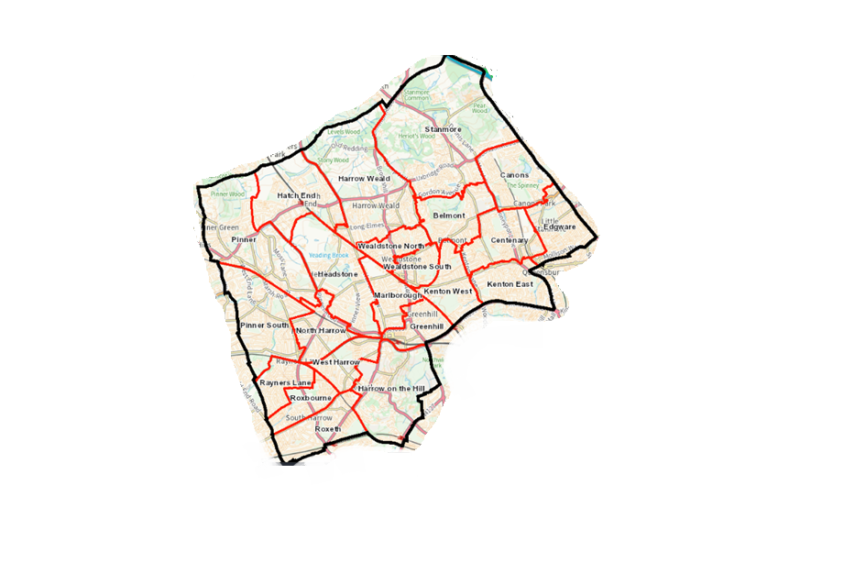**Designated area – Borough wide**

* Belmont,
* Canons,
* Centenary,
* Edgware,
* Greenhill,
* Harrow on the Hill,
* Harrow Weald,
* Hatch End,
* Headstone,
* Kenton East,
* Kenton West,
* Marlborough,
* North Harrow,
* Pinner,
* Pinner South,
* Rayners Lane,
* Roxbourne,
* Roxeth,
* Stanmore,
* Wealdstone North,
* Wealdstone South,
* West Harrow.

**Appendix 2**

**Designated area - Housing Estates**

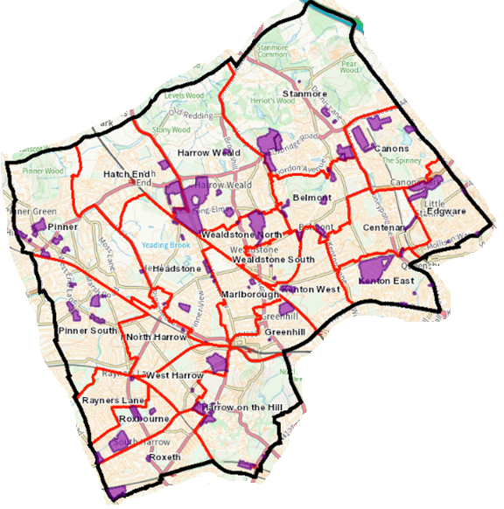

* Chaucer House Estate
* Arrowhead Parade Estate
* Mercer Place Estate
* Anmer Estate
* Edgware Golf Course Estate
* Oxhey Lane Estate
* Canon Croft Estate
* Anthoneys Estate
* Belmont Lodge Estate
* Belmont Circle Estate
* Byron Road Estate
* Canons Park Estate
* Christchurch Avenue Estate
* Churchill Place Estate
* Chigwellhurst Estate
* Dennis Lane Estate
* Cullington Close Estate
* George V Close Estate
* Elmgrove Estate
* Grove Estate
* Harrow View Estate
* Harrow Weald Park Estate
* Headstone Lane Estate
* High Road Estate
* Honister Place Estate
* Kenmore Park Estate
* Kenton Lane Estate
* Kingsfield Estate
* Little Common Estate
* Marsh Road Estate
* Mountside Estate
* Pinner Hill Estate
* Pinner Road (301) Estate
* Wealdstone House Estate
* West End Lane Estate
* Wolverton Road Estate
* Headstone (GLC) Estate
* Glebe Estate
* Manor House Estate
* Mill Farm Close Estate
* Moat Drive Estate
* Parkfield Estate
* Pinner Green Estate
* College Hill Road Estate
* Towers Estate
* Weald Village Estate
* Wealdstone House Estate
* Whittington Way Estate
* Woodlands Estate
* Woodlands Drive Estate
* Cottesmore Estate

**Appendix 3**

**Designated area -Parks and open spaces**

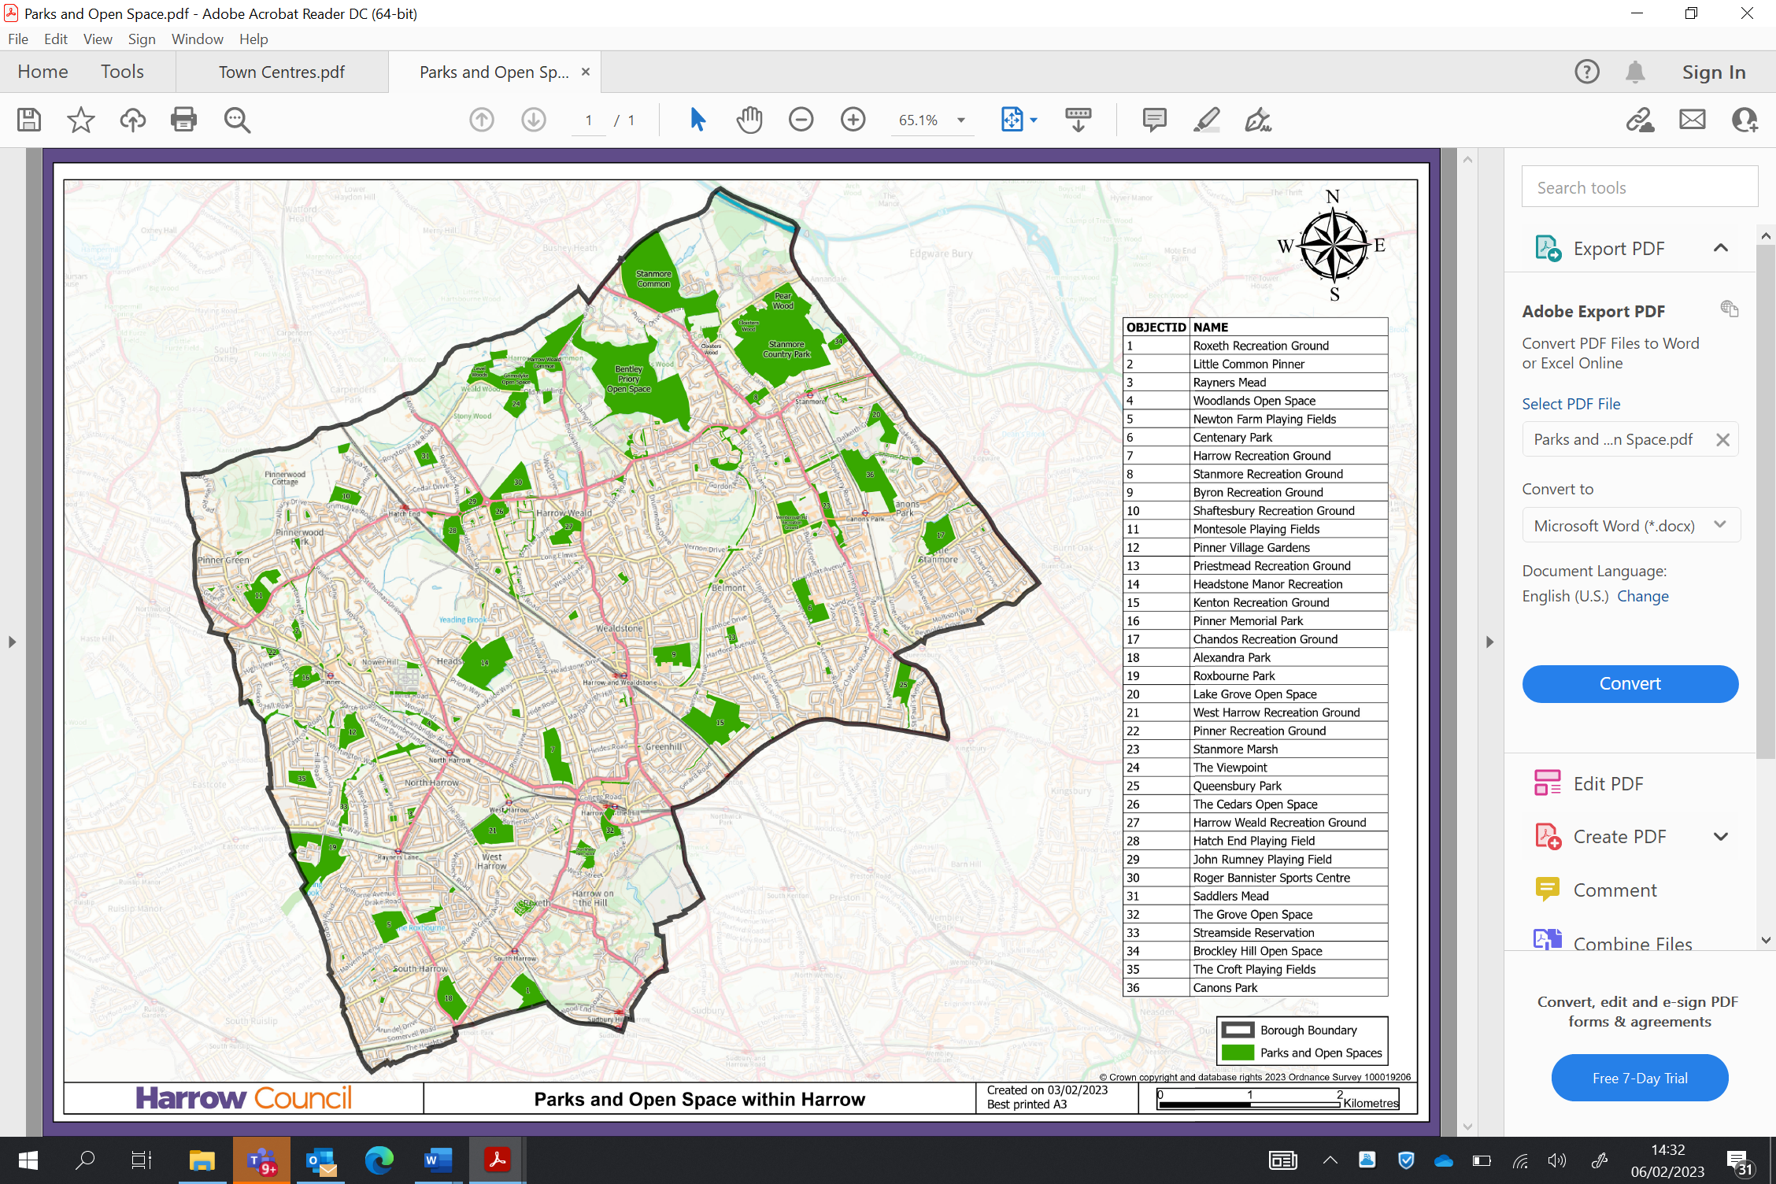

**Appendix 4 Designated area - Town Centres**

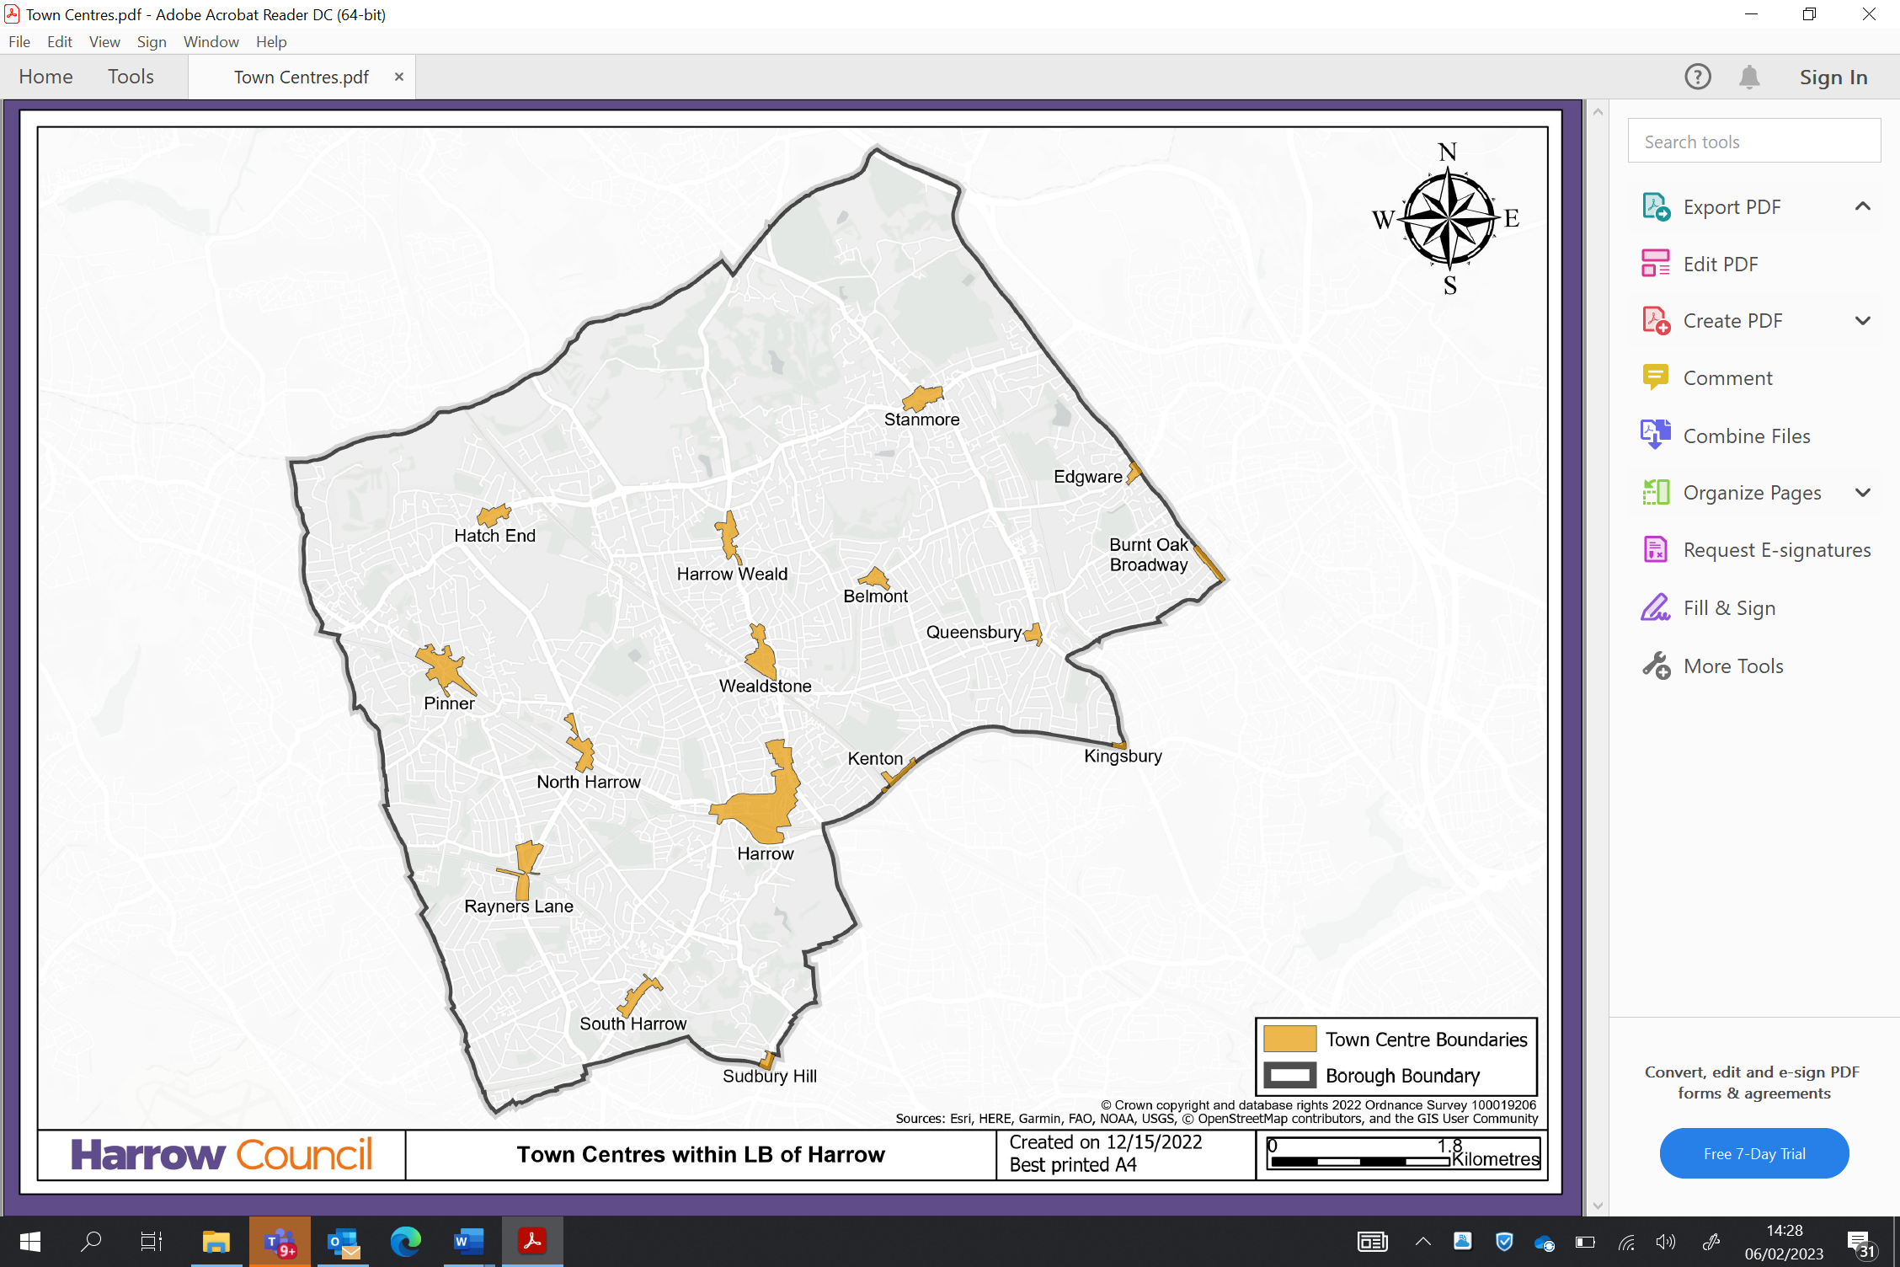

* **Harrow, Pinner, Stanmore, Wealdstone, Hatch End, Harrow Weald, South Harrow, North Harrow, Rayners Lane, Hatch End, Belmont, Sudbury Hill, Kenton, Kingsbury, Edgware and Burnt Oak.**

**Appendix 5**

**Designated area – Bentley Priory**

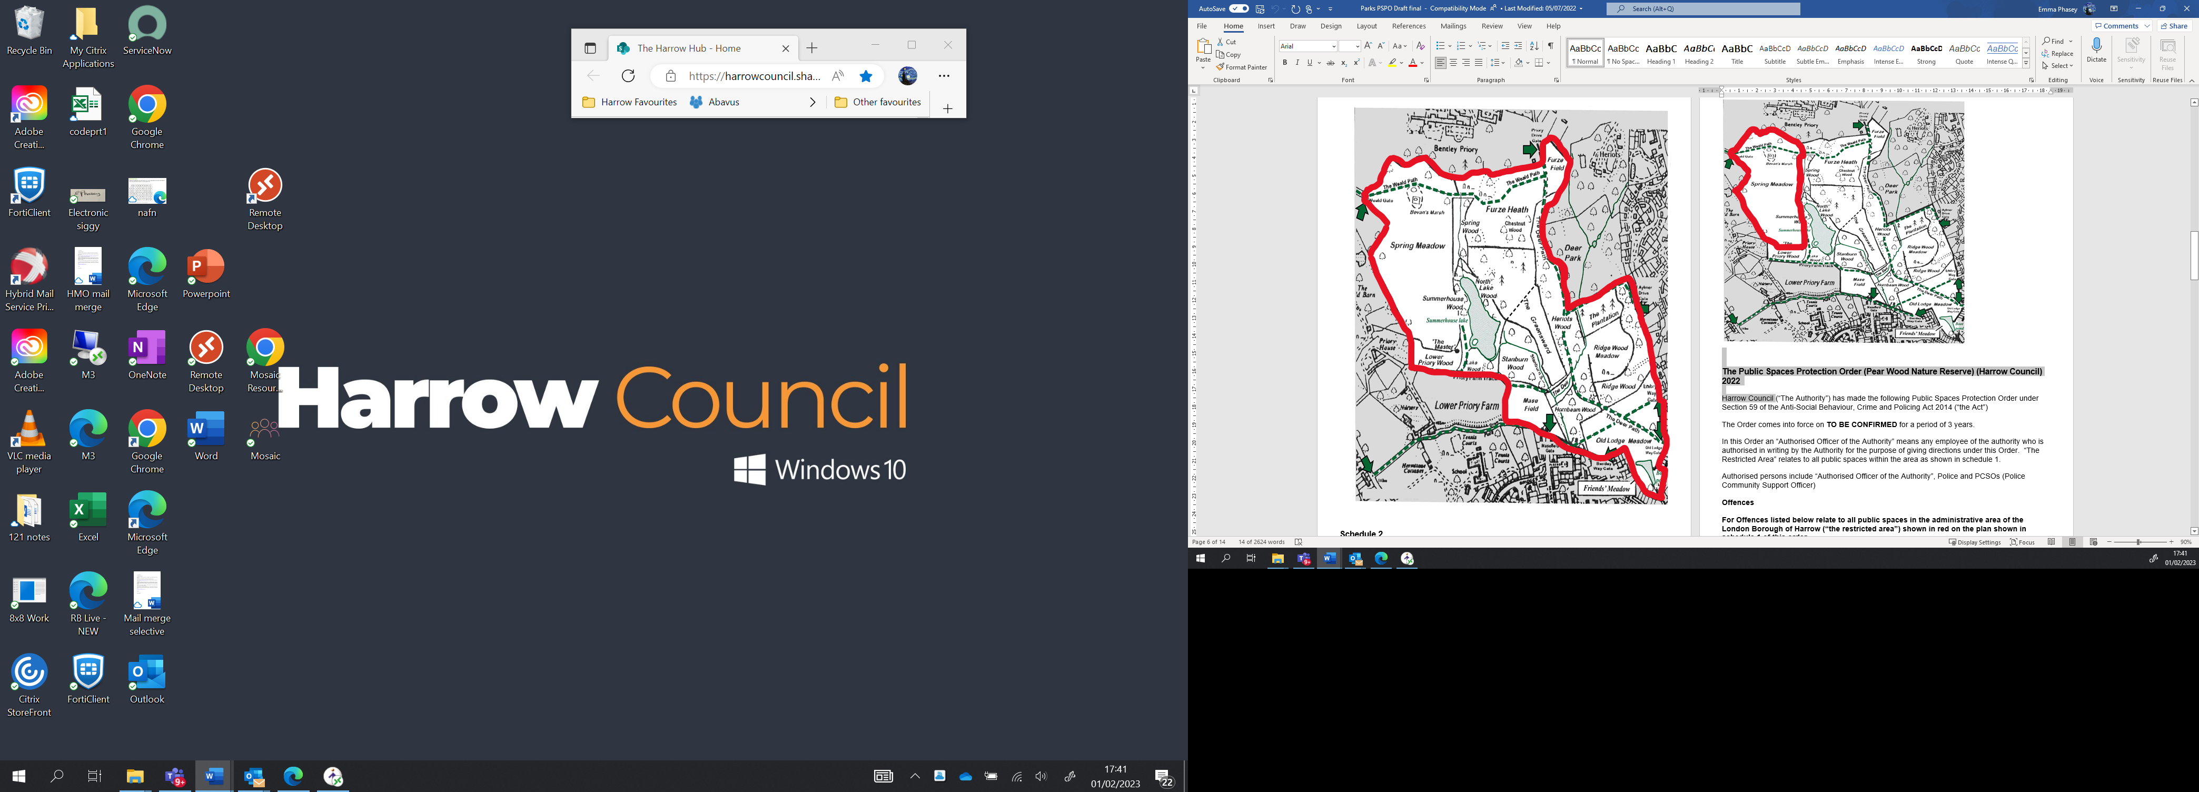

**Designated area Pinner Memorial Park**

**Designated area Viewpoint**

